SIMULATION EXPERIMENT – 1
1.Design, Realization and Performance Analysis of Butterworth IIR Low-Pass and High-Pass Digital Filters Using MATLAB
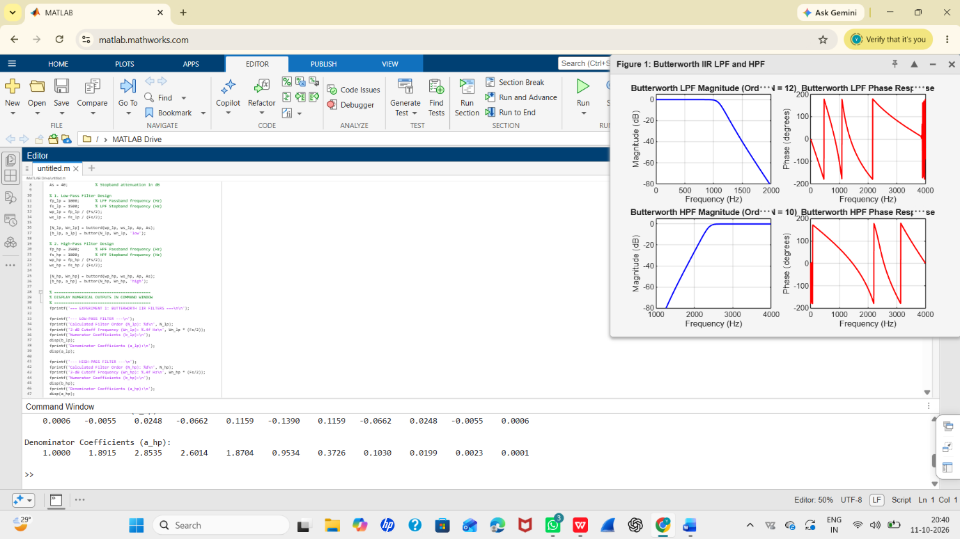
SIMULATION EXPERIMENT – 2
2. Design and Performance Analysis of Chebyshev Type-I IIR Low-Pass and High-Pass Filters Using MATLAB
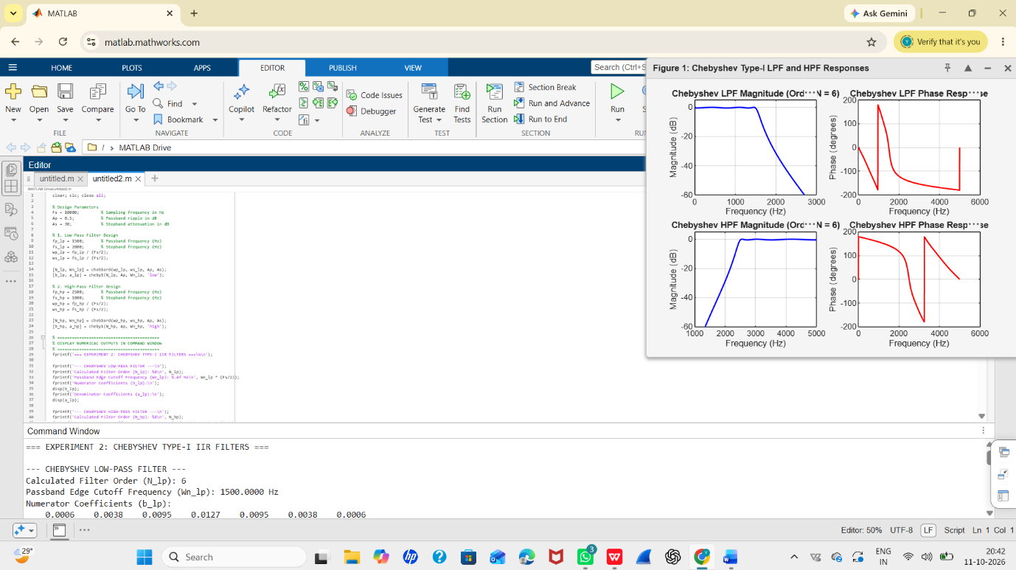

SIMULATION EXPERIMENT – 3
Design of IIR Filters Using Impulse Invariance and Bilinear Transformation Methods Using MATLAB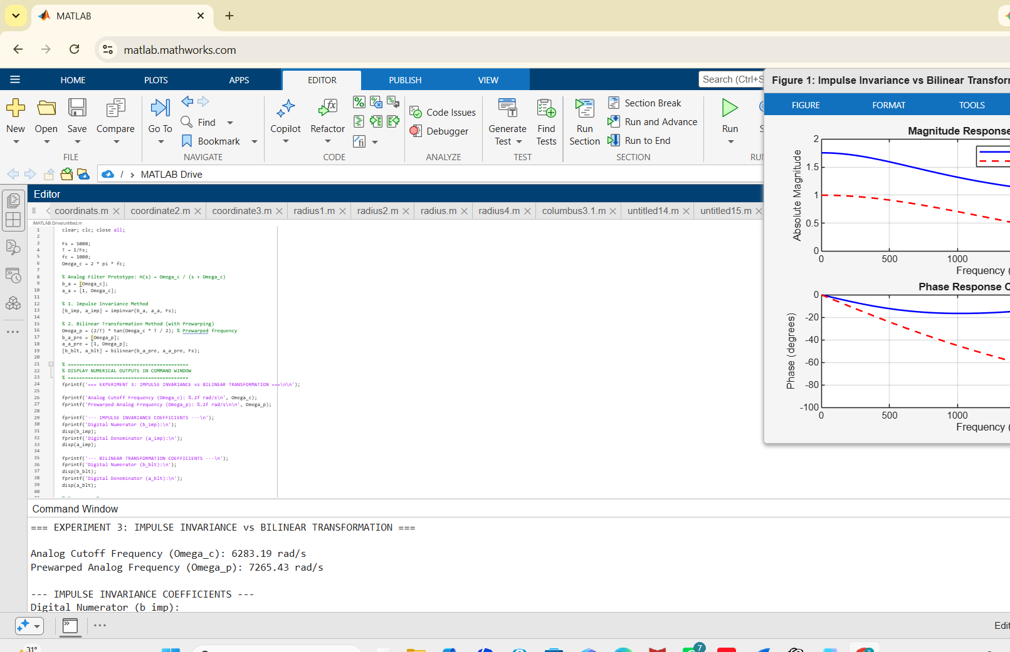
SIMULATION EXPERIMENT – 4
Design and Comparative Analysis of Butterworth, Chebyshev and Elliptic IIR Filters Using MATLAB